**Practical No. 10**

1. **Persisting Data using Shared Preferences.**

**Designing UI**

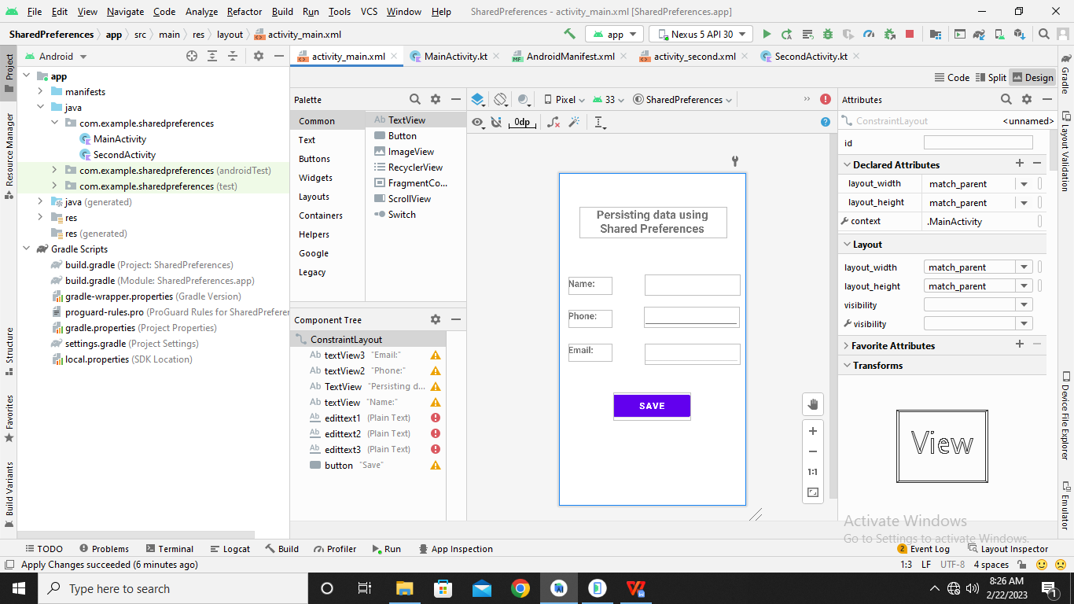

**Code:**

**MainActivity.kt**

**package** com.example.sharedpreferences  
  
**import** android.content.Intent  
**import** android.content.SharedPreferences  
**import** androidx.appcompat.app.AppCompatActivity  
**import** android.os.Bundle  
**import** android.widget.Button  
**import** android.widget.EditText  
**import** android.widget.Toast  
  
**class** MainActivity : AppCompatActivity() {  
 **lateinit var sharedPreferences**:SharedPreferences  
  
 **override fun** onCreate(savedInstanceState: Bundle?) {  
 **super**.onCreate(savedInstanceState)  
 setContentView(R.layout.*activity_main*)  
  
 **var** text1:EditText=findViewById(R.id.*edittext1*)  
 **var** text2:EditText=findViewById(R.id.*edittext2*)  
 **var** text3:EditText=findViewById(R.id.*edittext3*)  
  
 **var** btn:Button=findViewById(R.id.*button*)  
  
 btn.setOnClickListener **{  
 var** name=text1.*text*.toString()  
 **var** phone=text2.*text*.toString()  
 **var** email=text3.*text*.toString()  
  
 **sharedPreferences**=getSharedPreferences(**"MyPreferences"**, *MODE_PRIVATE*)  
 **var** editor:SharedPreferences.Editor=**sharedPreferences**.edit()  
 editor.putString(**"Name:"**,name)  
 editor.putString(**"Phone:"**,phone)  
 editor.putString(**"Email:"**,email)  
 editor.commit()  
  
 Toast.makeText(*applicationContext*,**"All preferences are saved..."**,Toast.*LENGTH_LONG*).show()  
 **var** intent1:Intent= Intent(*applicationContext*,SecondActivity::**class**.*java*)  
 startActivity(intent1)  
 **}** }  
}

**AndroidManifest.xml**

*<?***xml version="1.0" encoding="utf-8"***?>*<**manifest xmlns:android="http://schemas.android.com/apk/res/android"  
 package="com.example.sharedpreferences"**>  
  
 <**application  
 android:allowBackup="true"  
 android:icon="@mipmap/ic_launcher"  
 android:label="@string/app_name"  
 android:roundIcon="@mipmap/ic_launcher_round"  
 android:supportsRtl="true"  
 android:theme="@style/Theme.SharedPreferences"**>  
 <**activity  
 android:name=".SecondActivity"  
 android:exported="true"** >  
 <**intent-filter**>  
 <**action android:name="android.intent.action.SecondActivity"** />  
 <**category android:name="android.intent.category.DEFAULT"** />  
 </**intent-filter**>  
 </**activity**>  
 <**activity  
 android:name=".MainActivity"  
 android:exported="true"**>  
 <**intent-filter**>  
 <**action android:name="android.intent.action.MAIN"** />  
 <**category android:name="android.intent.category.LAUNCHER"** />  
 </**intent-filter**>  
 </**activity**>  
 </**application**>  
  
</**manifest**>

**SecondActivity.kt**

**package** com.example.sharedpreferences  
  
**import** android.content.SharedPreferences  
**import** androidx.appcompat.app.AppCompatActivity  
**import** android.os.Bundle  
**import** android.widget.Toast  
  
**class** SecondActivity : AppCompatActivity() {  
 **override fun** onCreate(savedInstanceState: Bundle?) {  
 **super**.onCreate(savedInstanceState)  
 setContentView(R.layout.*activity_second*)  
  
 **var** sharedPreferences:SharedPreferences=getSharedPreferences(**"MyPreferences"**, *MODE_PRIVATE*)  
 **var** editor:SharedPreferences.Editor=sharedPreferences.edit()  
 **var** n=sharedPreferences.getString(**"Name:"**,**" "**)  
 **var** p=sharedPreferences.getString(**"Phone:"**,**" "**)  
 **var** e=sharedPreferences.getString(**"Email:"**,**" "**)  
 Toast.makeText(*applicationContext*,**"Data read is... \nName:"**+n+**" \nPhone:"**+p+**" \nEmail:"**+e,Toast.*LENGTH_LONG*).show()  
 }  
}

**Output:**

